 | Testing and Training Center of Farm Machinery  Department of Farm Machinery and Power Engineering  College of Agricultural Engineering and Technology  Junagadh Agricultural University  JUNAGADH – 362 001 (GUJARAT) | 
P | Phone : (0285) 2672080-90, Ext. 390 & 484; Fax : (0285) 2671018

SPECIFICATION SHEET OF TRACTOR OPERATED REAPER CUM BINDER

1 | General:
 | a) | Name | :
 | b) | Type | :
 | c) | Make | :
 | d) | Serial Number | :
 | e) | Model | :
 | f) | Year of manufacture | :
 | g) | Nominal size (mm) | :
 | h) | Types of crop recommended | :
 | i) | Recommended source of power as per applicant | :
 | j) | Selling price in India | :

2 | CONSTRUCTIONAL DETAILS
2.1 | Reaper:
 | a) | Cutter bar assembly | :
 |  | Working width with shoes (mm) | :
 |  | Effective cutter bar width (mm) | :
 |  | No. and spacing of knife guard (mm) | :
 |  | No. and type of knife blades | :
 |  | Details of knife drive | :
 |  | Knife safety arrangement | :
 |  | Knife stroke (mm) | :
 |  | Stroke per minute (corresponding to _____ rpm of PTO shaft) | :
 |  | Arrangement and range of adjusting cutting height (mm) | :
 |  | Height of cutter bar in transport position (mm) | :
 |  | Type of crop divider | :
 |  | Type of crop conveyance | :
 |  | Arrangement for lifting lodged crop | :

 | b) | Specification of Knife sections:
 |  | Type

 | Sr. | Desig. | mm | 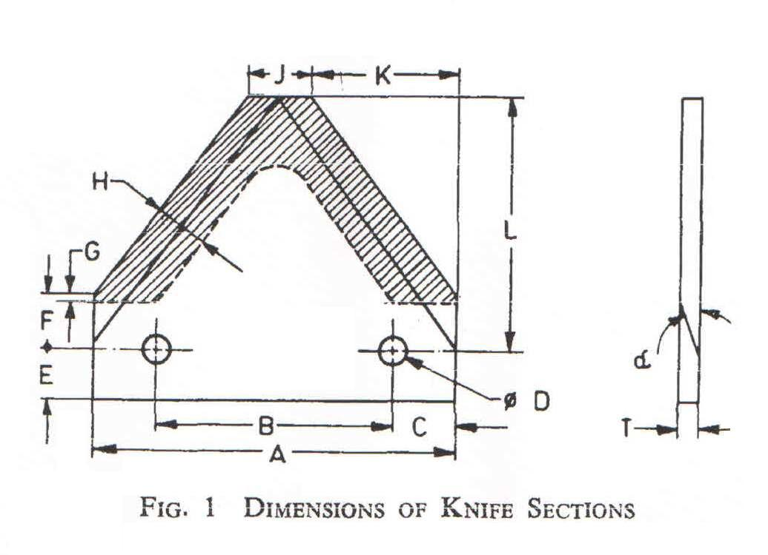
 | 1. | A
 | 2. | B
 | 3. | C
 | 4. | D
 | 5. | E
 | 6. | F
 | 7. | G
 | 8. | H
 | 9. | J
 | 10. | K
 | 11. | L
 | 12. | T
 | 13. | α
 | Marking:
 | - Manufacturer’s name or recognized trade-mark
 | - Batch or code number, and
 | - Type and thickness.

 | c) | Specification of Knife guards | :

 | Sr. |  | Desi | mm | 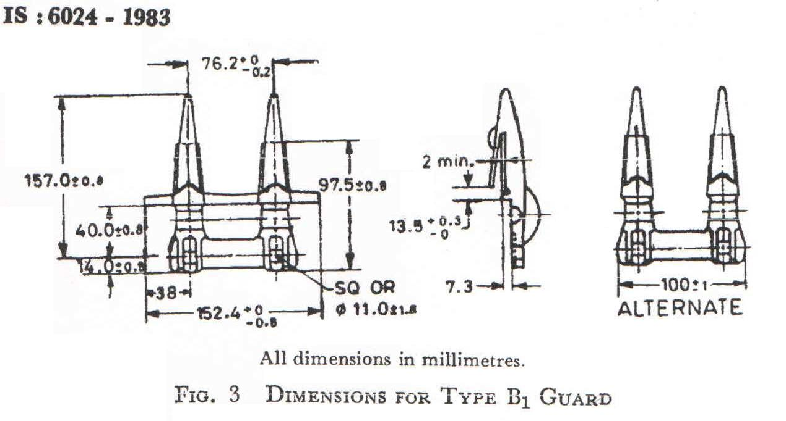
 | 1. |  | A
 | 2. |  | B
 | 3. |  | C
 | 4. |  | D
 | 5. |  | E
 | 6. |  | F
 | 7. |  | G
 | 8. |  | H
 | 9. |  | I
 | 10. |  | J
 | 11. |  | K
 | 12. |  | L
 |  | Marking
 |  | - Manufacturer’s name or recognized trade-mark
 |  | - Type, and
 |  | - Batch or code number.

 | d) | Specification of Knife backs |  |  |  | :
 |  | Material
 | Sr. |  | Desig. | Dimension(mm) | 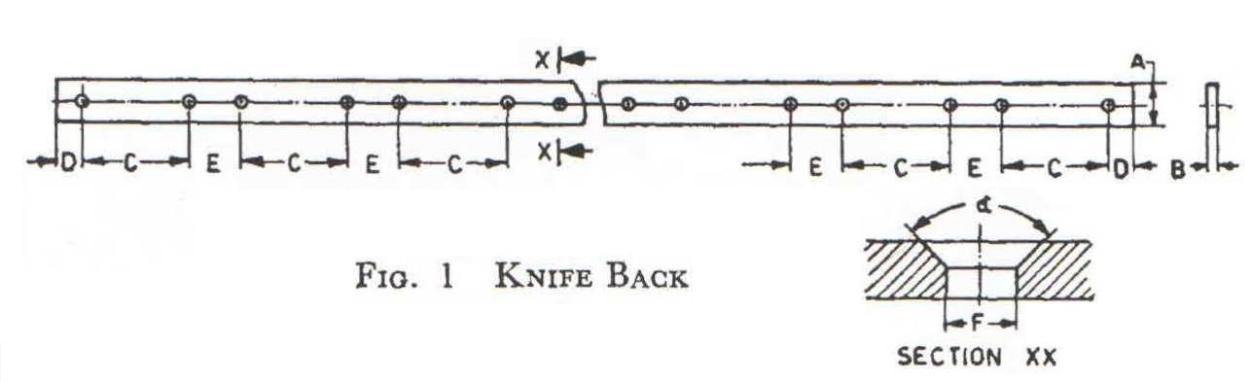
 | 1. |  | A
 | 2. |  | B
 | 3. |  | C
 | 4. |  | D
 | 5. |  | E
 | 6. |  | F
 | 7. |  | α
 | Marking
 | - Manufacturer’s name or recognized trade-mark and
 | - Batch or code number.

2.2 | Crop collector mechanism:
 | a) | Type |  |  |  |  | :
 | b) | Arrangement oscillating of fork |  |  |  |  | : | Fork | Finger
 |  | Upper unit |  |  |  |  | :
 |  | Middle unit |  |  |  |  | :
 |  | Lower unit |  |  |  |  | :
 | c) | Height from the bottom surface to the tip of fingers (mm):
 |  | Upper fork |  |  |  |  | :
 |  | Middle fork |  |  |  |  | :
 |  | Lower fork |  |  |  |  | :
 | d) | Stroke length of a crop collector unit (mm) |  |  |  |  | :
 | e) | Speed (rpm) of crop collector shaft corresponding to 400 rpm of PTO |  |  |  |  | :
 | f) | Any safety mechanism, for overloading |  |  |  |  | :
 | g) | Method of mounting |  |  |  |  | :
 |  | RHS collector shaft | :
 |  | LHS collector shaft | :
2.3 | Tying mechanism:
 | a) | Type |  |  | :
 | b) | Method of drive |  |  | :
 | c) | Dimension of needle (mm) |  |  | :
 |  | Peripheral length |  |  | :
 |  | Width |  |  | :
 |  | Thickness |  |  | :
 | d) | Method of mounting |  |  | :
 | e) | Method of tying |  |  | :
 | f) | safety mechanism |  |  | :
2.4 | Density control mechanism:
 | a) | Type |  |  | :
 | b) | Range of adjustment (kg) |  |  | :
2.5 | Twine:
 | a) | Type |  |  | :
 | b) | Make |  |  | :
 | c) | Size (mm) |  |  | :
 |  | Diameter |  |  | :
 |  | Height |  |  | :
 |  | Weight (kg) |  |  | :
 | d) | Twine rope size |  |  | :
 |  | Length (m) |  |  | :
 |  | Diameter (mm) |  |  | :

2.5.1 | Twine bundle stand:
 | a) | Length | :
 | b) | Diameter | :
 | c) | Thickness | :
2.5.2 | Twine path |  | :

2.6 | Knotter:
 | a) | Type | :
 | b) | Method of drive | :
 | c) | No. of teeth on a gear of knotter shaft:
 |  | Bill hook gear | :
 |  | Drive gear/crown gear | :
 | d) | No. of revolution of a knotter shaft when it engaged on to 400 rpm of PTO | :
 | e) | knotter type
 | f) | Method knotting | :
 | f) | Safety mechanism | :
2.7 | Bundle expeller unit:
 | a) | Type | :
 | b) | Size (mm)
 |  | Length of travel | :
 |  | Width | :
 |  | Height | :
 | c) | Thickness of M.S sheet (mm) | :
 | d) | Method of drive | :
 | e) | No. of teeth on a sprocket | :
 |  | Driver | :
 |  | Driven | :
 | f) | Total reduction ratio | :
 | g) | Speed (rpm) of bundle expeller conveyor corresponding to 400 rpm of PTO | :
 | h) | Size of chain(mm)
 |  | No. | :
 |  | Dia. of roller | :
 |  | Pitch | :
 |  | Length | :
 |  | No. of roller | :

2.7.1 | Guider fork:
 | a) | Type | :
 | b) | No. and spacing (mm) | :
 | c) | Size (mm)
 |  | Base length | :
 |  | Slanted length | :
 |  | Height | :
 |  | Thickness | :
2.7.2 | Expeller:
 | a) | Type | :
 | b) | Method of drive | :
 | c) | No. and location | :
 | d) | Size (mm) bottom expeller | :
 |  | Peripheral length | :
 |  | Width | :
 |  | Thickness | :
 | e) | Size (mm) top expeller | :
 |  | Length | :
 |  | Base Width | :
 |  | Thickness | :
 | f) | Speed of expeller shaft at 400 rpm of PTO | :
2.7.3 | Door:
 | Type |  | :

2.8 | Gear box:
 | a) | Type | :
 | b) | No. of teeth on gear | :
 |  | Driver | :
 |  | Driven | :
 | c) | Reduction ratio power input shaft to crown gear power output shaft | :
 | d) | Effective length of spline (mm) | :
 | e) | No. of spline
2.9 | Types of hitch and its details:
 | a) | Type | :
 | b) | Constructional details | :

Specification of Hitch Pyramid as per IS: 4468-(Part-I)-2001

Sr. | Dimension  (Refer Fig.1) | Description | Measurement
Upper Hitch attachments
1 | d₁ | Diameter of hitch pin hole
2 | b’₁ | Width between inner faces of yoke
3 | b’₂ | Width between outer faces of yoke
Lower hitch points
4 | D₂ | Dia. of hitch pin
5 | b’₃ | Linch pin hole distance
6 | l | Lower hitch point span
Other dimensions
 | Diameter of linch pin hole
7 | d | For upper hitch pin
8 |  | For lower hitch pin
9 | h | Mast height

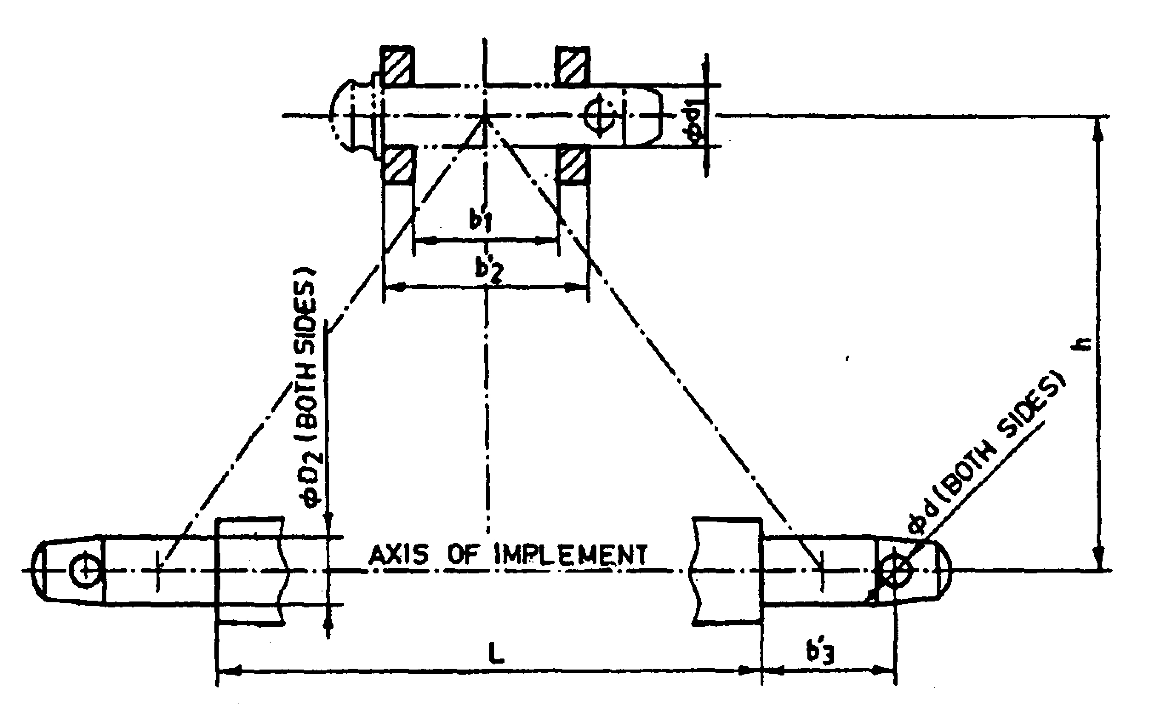
Fig. 1 : Implement Hitch Attachment as per IS
2.10 | Propeller shaft (Refer Fig. 2):
 | a) | Type |  | :
 | b) | Length of shaft (mm)
 |  | Minimum |  | :
 |  | Maximum |  | :
 | c) | Mass of shaft (kg) |  | :
 | d) | Provision for locking |  | :
 | e) | Safety provision |  | :

Sr. | Notations  (Refer Fig.4) | Dimensions
1 | D Φ
2 | d Φ
3 | W
4 | B

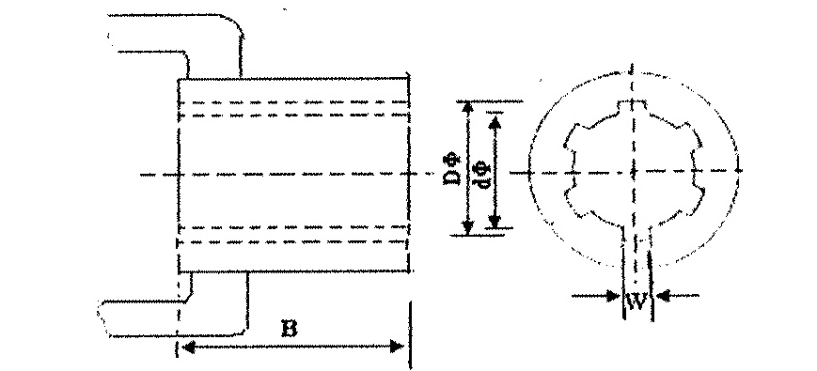
Fig. 2 : Propeller Shaft Insert Dimensions
2.11 | Splined end of Reaper input shaft (Ref. Fig. 3):

Sr. | Specification/ Notations  (Refer Fig.3) | Measurement
1 | PTO Type
2 | Nominal speed (rpm)
3 | Nominal dia.(mm)
4 | Number and type of splines
Dimensions (mm)
5 | D Φ
6 | d Φ
7 | B Φ
8 | A Φ
9 | W
10 | a
11 | b
12 | c
13 | x
14 | B
15 | h

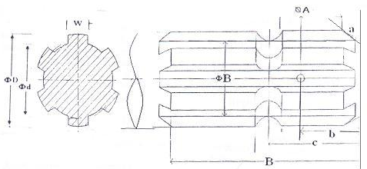
Fig. 3: Dimension of Implement Power Input Shaft
2.12 |  | Safety device |  | :
3 | Safety mechanism :
 | a) |  | Belt drive provided at the main pulley | :
 | b) |  | A spring loaded plate | :
 | c) |  | Drawbar spring | :

4 | Greasing and Oiling point:
 | a) | No. of greasing point | :
 | b) | No. of oiling point | :

4.1 | Lubrication schedule:
A) | Daily greasing point:
 | a) | PTO drive shaft | :
 | b) | Bracket housing at spring tensioner | :
 | c) | Fork throw bush bearings (2 pair) | :
 | d) | Main pulley | :
 | e) | Needle shaft | :
 | f) | Binder cone shaft | :
 | g) | Binder cone | :
 | h) | Knotter | :
 | i) | Rocker mount at oscillate arm of a cutter bar | :
 | j) | Expeller roller (LHS) | :
 | Seasonally greasing point (after _______h of operation):
 | a) | Gear box housing chamber | :
 |  | Total greasing point | :
B) | Daily oiling point
 | a) | Chain drive at bundle expeller unit | :
 | b) | Knife blade and knife bar | :
 | Annually oiling point:
 | a) | Gearbox | :
 |  | Total oiling point | :

5 | Overall dimensions (mm) :
 | a) | Transportation | :
 |  | Length | :
 |  | Width | :
 | b) | Field operation | :
 |  | Length | :
 |  | Width | :
 | c) | Height | :

6 | Total mass (kg) | :
7 | Color of implement | :

Place:
Date:
Signature : _________________________

Name : _________________________

Designation: ________________________

